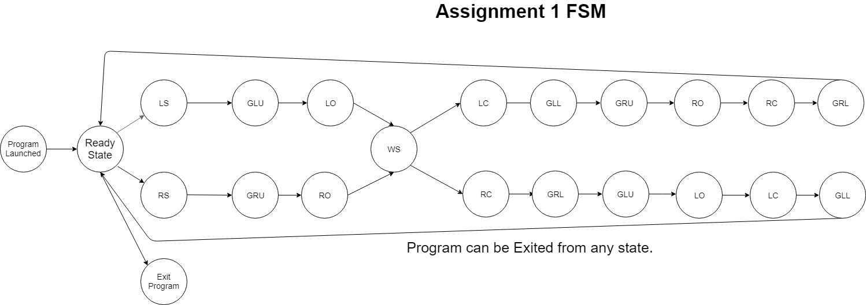

**List of states: Persistent Data:**

Ready State (Prompt State) **struct** person_details{   
LS - Left Scan **int** id; **(input)**  
RS - Right Scan **int** weight; **(input)**  
GLU - Guard left unlock **int** state;   
GRU - Guard right unlock **char** event[128]; **(input)**  
LO - Left open } **typedef** Person;  
RO - Right open  
WS - Weight scan **struct** controller_details {  
LC - Left close **int** error;  
RC - Right close **char** errorMsg[128]; **(output)**  
GLL - Guard left lock } **typedef** controller_response_t;  
GRL - Guard right lock  
EXIT - Exit the program

**Outputs:**

**const** **char** *outMessage[NUM_OUTPUTS] = {

"Enter the Person's ID:\n",

"Left door unlocked by Guard\n",

"Right door unlocked by Guard\n",

"Person opened left door\n",

"Person opened right door\n",

"Enter the Person's weight:\n",

"Left door locked by Guard\n",

"Right door locked by Guard\n",

"Exiting controller\n",

"Exit Display\n"

};

**Inputs:**

**const** **char** *inMessage[NUM_INPUTS] = {

"ls",

"rs",

"glu",

"gru",

"lo",

"ro",

"ws",

"lc",

"rc",

"gll",

"grl",

"exit"

};

**Conditions:**

In ***left_open*** and ***right_open*** state functions, we have the following condition:

**if** (person.weight == 0) {

**if** (strcmp(person.event, inMessage[*WEIGHT_SCAN_INPUT*]) == 0) {

person.state = *WEIGHT_SCAN_STATE*;

**if** (**MsgSend**(coid, &person, **sizeof**(person), &response, **sizeof**(response)) == -1) {

**perror**("MsgSend failed");

**exit**(EXIT_FAILURE);

}

**return** weight_scan;

}

**return** left_open;

}

In ***guard_left_lock*** and ***guard_right_lock*** state functions, we have the following condition:

**guard_left_lock**:

**if** (direction == 1){

**if** (strcmp(person.event, inMessage[*GUARD_RIGHT_UNLOCK_INPUT*]) == 0) {

person.state = *GUARD_RIGHT_UNLOCK_STATE*;

**if** (**MsgSend**(coid, &person, **sizeof**(person), &response, **sizeof**(response)) == -1) {

**perror**("MsgSend failed");

**exit**(EXIT_FAILURE);

}

**return** guard_right_unlock;

}

**return** guard_left_lock;

}

**guard_right_lock:**

**if** (direction == 2) {

**if** (strcmp(person.event, inMessage[*GUARD_LEFT_UNLOCK_INPUT*]) == 0) {

person.state = *GUARD_LEFT_UNLOCK_STATE*;

**if** (**MsgSend**(coid, &person, **sizeof**(person), &response, **sizeof**(response)) == -1) {

**perror**("MsgSend failed");

**exit**(EXIT_FAILURE);

}

**return** guard_left_unlock;

}

**return** guard_right_lock;

}